CONTRACT MONTHLY CLAIM SYSTEM (CMCS) – PROTOTYPE (POE PART 1)

Richard ernest Sebola

St10441486

[Year]

**Table of Contents**

1. Introduction (Background & Objectives)  
........................................................................... 1

2. Design Documentation  
..................................................................................................... 2

Design Choices and GUI Layout .......................................................................................... 2

Data Model and Database Structure ..................................................................................... 2

Assumptions and Constraints ............................................................................................... 2

Project Plan Overview ......................................................................................................... 2

Conclusion ........................................................................................................................... 2

3. UML Class Diagram (Database Model) ...........................................................................

Entities and Attributes .......................................................................................................... 3

Relationships ........................................................................................................................ 3

Diagram ................................................................................................................................ 3

Explanation .......................................................................................................................... 3

4. Project Plan......................................................................................................................... 4

5 GUI Screenshots (Prototype Evidence)........................................................................... 5

Dashboard ............................................................................................................................ 5

Submit Claim form ............................................................................................................... 5

Verify Claims (table with Approve buttons) ......................................................................... 5

Track Claims ........................................................................................................................ 5

Login & Register .................................................................................................................. 5

6. Version Control Evidence (GitHub) ................................................................................. 6

7. Conclusion ........................................................................................................................ 7

8.Reference list........................................................................................................................ 8

**1. Introduction (Background & Objectives)**

The Contract Monthly Claim System, or CMCS, that's the prototype web app they built. It came from the Portfolio of Evidence, you know, for the PROG6212 module. The whole idea is to make submitting monthly claims simpler for independent contractor lecturers. Verifying and approving them without the usual hassle. In practice, it involves lots of people, like the lecturers, program coordinators, and academic managers. You have to check hours worked, rates, and all that supporting paperwork real carefully.

This POE aims to show some understanding of C# GUI in the .NET Core environment. Applying theory to an actual project. Right now, it's a non-functional prototype. It focuses on design, layout, and the overall flow. Not the back-end or database stuff yet. Still, it gives a solid idea of how it'd work in reality. Makes the UI intuitive and user-friendly, pretty much. The scope for Part 1 of the POE includes. **Planning and documentation**, including design explanations, assumptions, and constraints.

* A **UML class diagram** that models the database structure for claims, users, and supporting documents.
* A **project plan** outlining the tasks, dependencies, and timeline for prototype development.
* A **graphical user interface (GUI) prototype**, developed in ASP.NET Core MVC, which demonstrates the key system workflows: claim submission by lecturers, verification by programme coordinators, approval by academic managers, and the ability to track claim status transparently.

Finishing up this first stage, you know, it sets things up nicely for the rest of the POE. Later on, we'll get into adding those functional features, hooking up the database, and putting in the authentication stuff. I mean, the main thing right now is just making sure the design is clear and documented pretty well. That way, the whole final system ends up being efficient, focused on the users, and it lines up with how the academic claim management process is supposed to go.

**2. Design Documentation**

The whole setup for this Contract Monthly Claim System prototype, or CMCS if you want to call it that, really comes down to making things easy and straightforward for lecturers handling their claims. You know, with a simple interface that fits whatever role someone's in. Right now, it's just a mock-up, nothing that actually works yet. It's all about showing how it should look and feel, before they add the real stuff in coming phases.

Design Choices and GUI Layout

They went with ASP.NET Core MVC for building this thing. Seems like a solid pick because it keeps everything separated nicely, scales well, and fits right into web apps. There's this shared layout file, _Layout.cshtml, that handles the consistent look across pages, like navigation and branding. Up top, you've got a nav bar that lets you jump quick to the dashboard or submitting claims, verifying them, approving, tracking, and even account stuff like logging in or signing up.

The dashboard is basically your starting point. Users see their role there, whether it's lecturer, programme coordinator, or academic manager, and get to the functions that match. Lecturers fill out a form for claims, putting in the month, hours worked, rate per hour, and some spot for docs, even if it's just a placeholder now. Over on verification, claims show up in a table so coordinators can check details and give the okay. Academic managers do something similar for the final sign-off. And tracking lets lecturers peek at where their claims stand, keeping the whole process transparent, you know.

Data Model and Database Structure

For the prototype, they've got this one Claim model with basics like Id, LecturerName, ClaimMonth, HoursWorked, HourlyRate, Status, and SupportingDocument. That's the bare minimum to handle a claim, really.

Later on, when it's real, this maps to a Claims table in the database. They'll add more, like Users for lecturers and admins with roles controlling access, SupportingDocuments to hold file info and paths for evidence uploads, and ClaimStatusHistory to track changes and audit everything. The UML class diagram in the report shows all that and how they connect.

Assumptions and Constraints

A few things they assumed for this prototype. First off, no real authentication or role stuff yet, but that'll come later. Second, document uploads are faked with a text box, not actual files. And approvals are just shown with messages popping up, no database changes happening.

Constraints wise, it's all front-end focus for this first part, no back-end saving data or linking up. That way, they can zero in on how usable it is, the layout, and making workflows clear for roles.

Project Plan Overview

The plan spread this out over three weeks. Week one was about gathering what was needed, sketching UML, and setting up the MVC basics. Second week, they built the dashboard, views for claims, and threw in some sample data. Last week went to tweaking the UI, writing docs, and getting ready for submission, like the UML, plan, and report in Word. They kept version control going with at least five GitHub commits, each with notes describing what happened.

This stage sets up a good base for what's next. With the GUI clear, model in place, and roadmap sketched, the prototype shows the claim flow in a way that's structured but not overwhelming. When they layer on the functions later, it'll hit the marks for tech and ease of use.

**3. UML Class Diagram (Database Model)**

The database design for the Contract Monthly Claim System (CMCS) is represented using a **UML class diagram**, which models the core entities, their attributes, and relationships. This diagram provides a blueprint for how data will be structured and stored once database functionality is introduced in later stages of the project.

**Entities and Attributes**

* **User (Lecturer/Staff):** Represents individuals who interact with the system. Key attributes include UserId, Username, Password, FullName, and Role. Roles are defined as Lecturer, Programme Coordinator, or Academic Manager, each with specific permissions.
* **Claim:** Stores claim details submitted by lecturers. Attributes include ClaimId, LecturerId (foreign key to User), ClaimMonth, HoursWorked, HourlyRate, Status, and SupportingDocId.
* **SupportingDocument:** Stores metadata about uploaded files, such as DocId, FileName, and FilePath. Each claim may have one or more associated supporting documents.
* **ClaimStatusHistory:** Records the history of status changes for each claim. Attributes include HistoryId, ClaimId, Status, ChangedBy, and ChangedAt. This ensures an audit trail is maintained.

**Relationships**

* A **User** can submit multiple **Claims**, but each claim is linked to only one user.
* A **Claim** may reference zero or more **SupportingDocuments**, depending on whether evidence is required.
* A **Claim** can multiple entries in the **ClaimStatusHistory**, reflecting its progression through the workflow (e.g., Pending → Verified → Approved).

**Diagram**

*Figure 1: UML Class Diagram for CMCS Database Schema*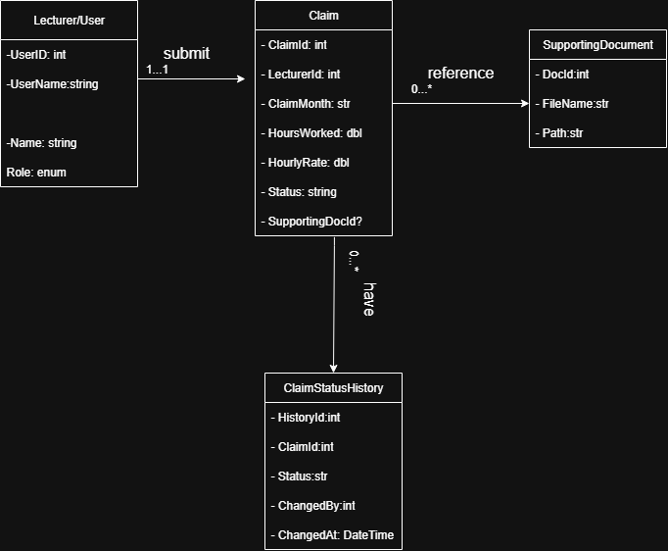

**Explanation**

The diagram lays out the logical setup for the database. It helps track and handle claims in a solid way. You know, by breaking everything down into users, claims, documents, and history. That kind of arrangement keeps the data reliable. It allows for full audits. And it scales without a ton of problems.

Take the ClaimStatusHistory entity for example. It logs every action that happens on a claim. That gives you real transparency. Oh and, putting supporting documents in their own separate area avoids all that duplication mess. File management gets a lot easier, basically.

This structure fits right in with the MVC prototype we're building now. The Claim class we have matches the Claims entity in the diagram. We'll add in things like User and SupportingDocument entities later on. You know, during those next development phases. So the prototype ends up connecting to a full working back-end.

**4. Project Plan**

The project plan for the Contract Monthly Claim System (CMCS) prototype was structured over a three-week period to cover design, development, documentation, and submission requirements. Tasks were broken down into manageable units, with dependencies identified to ensure logical progression.

| Week | Task | Dependencies | Duration |
| --- | --- | --- | --- |
| Week 1 | Gather requirements and identify assumptions | – | 1 day |
| Week 1 | Draft UML class diagram (initial design) | Requirements identified | 1 day |
| Week 1 | Create MVC project skeleton and layout page | – | 2 days |
| Week 2 | Implement Dashboard, Submit, Verify, and Track views | Layout completed | 3 days |
| Week 2 | Define Claim model and seed sample data | UML draft completed | 2 days |
| Week 2 | Apply CSS styling and ensure responsive layout | Core views in place | 2 days |
| Week 3 | Finalise UML diagram and refine design documentation | Prototype complete | 2 days |
| Week 3 | Prepare project plan and report (Word document) | Documentation drafted | 2 days |
| Week 3 | Push at least 5 commits to GitHub with descriptive messages | Development tasks completed | 1 day |

**5. GUI Screenshots (Prototype Evidence)**

Dashboard

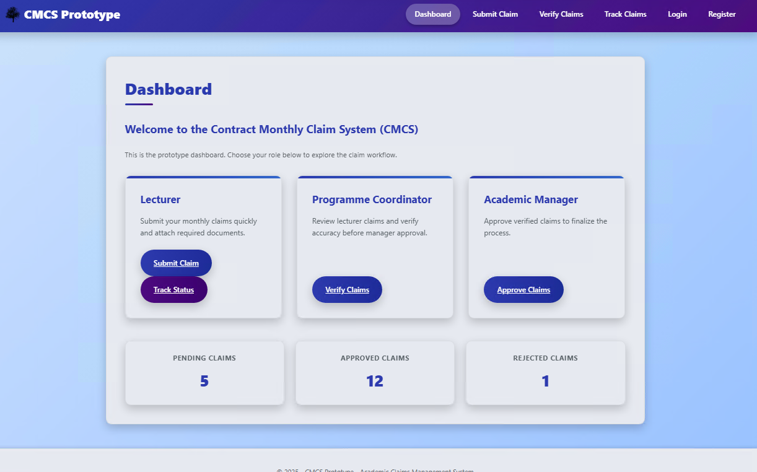

Submit Claim

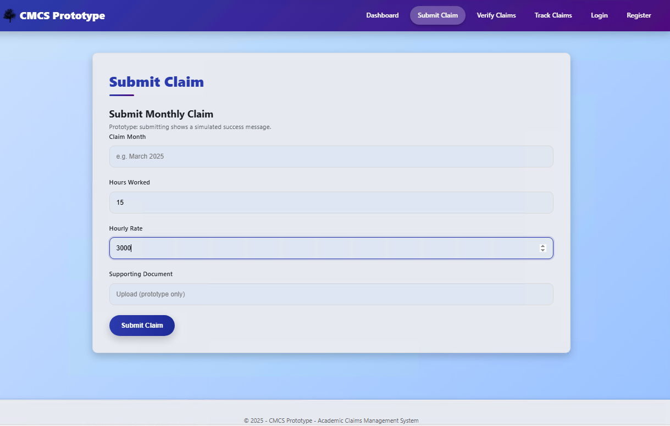

Verify Claims (table with Approve buttons)

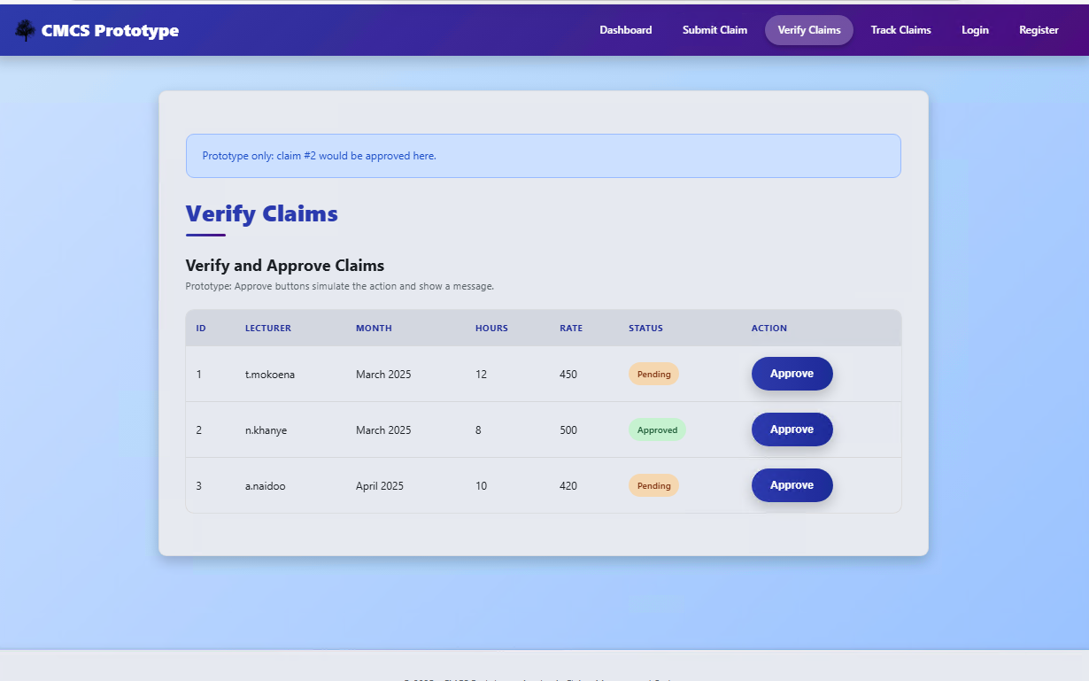

Track Claims

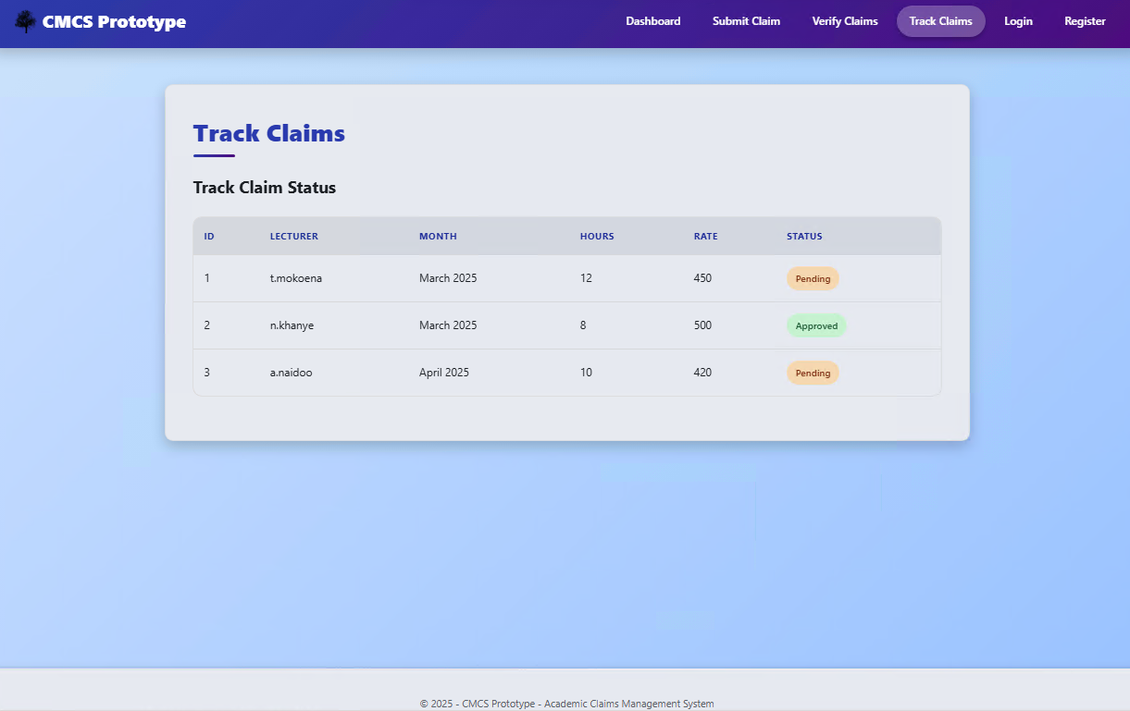

Login

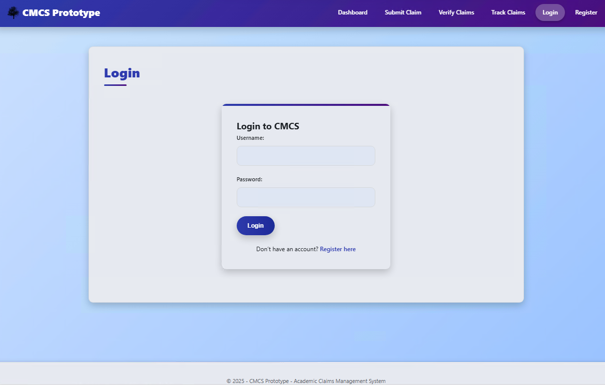

Register

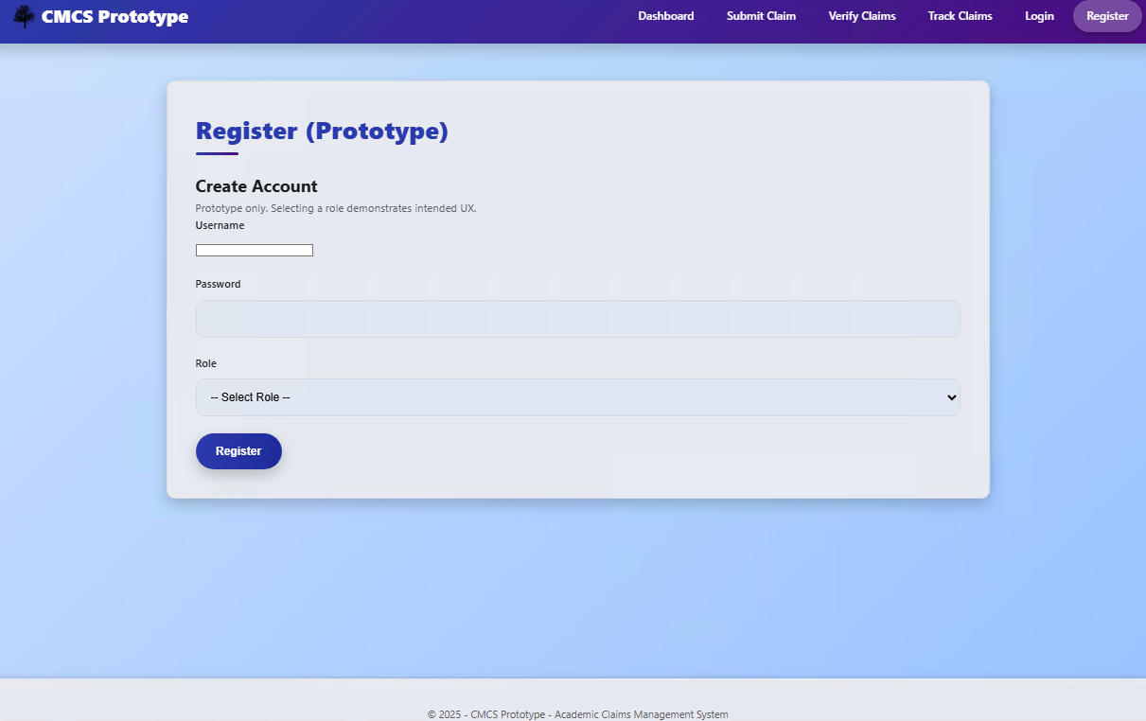

**6. Version Control Evidence (GitHub)**

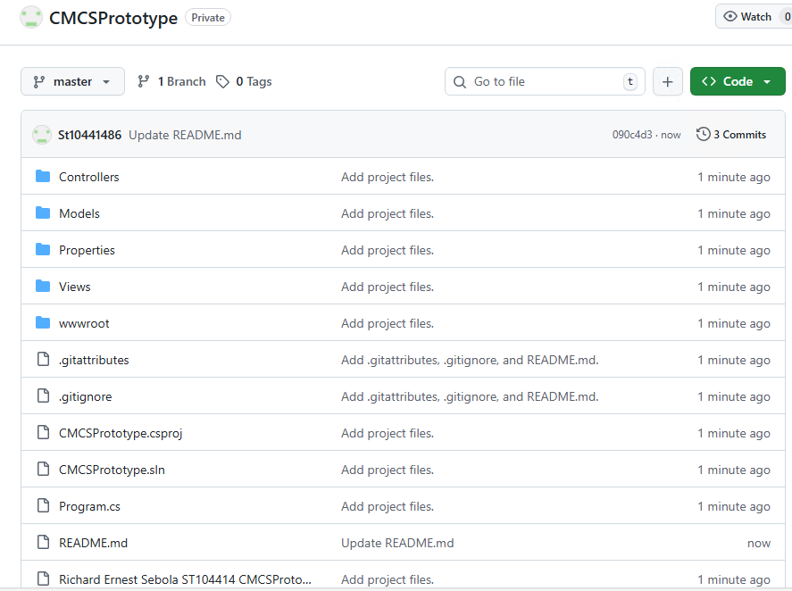

**7. Conclusion**

The Contract Monthly Claim System prototype. That's for Part 1 of the Portfolio of Evidence. It lays out the planning and design work, you know, and gets the front-end going for how the app should function. We've hit all the deliverables in here. Like, we documented the reasons behind our choices. Put together a UML class diagram for the database structure. Sketched a project plan that actually makes sense. And built a basic GUI prototype with ASP.NET Core MVC.

This setup follows the workflows just about as we planned them. Lecturers can submit claims. Coordinators review them. Managers approve or reject. Oh and there's a tracking area, so lecturers see the status of their submissions all along the way. Right now, it's not fully operational. I mean, approvals are fake. Document uploads are dummies. No real database storage happening. Still, it establishes the foundation. For when we implement the actual features in Part 2.

We've put a ton of emphasis on usability. And navigation that's clear based on user roles. The UML diagram and project plan guide everything technically. With a schedule that fits. We used version control the whole time too. Lots of commits on GitHub. They show the build-up step by step.

Design and planning are complete at this point. So yeah, the project's set for Part 2. We'll add the back-end components there. Login functionality. Real data saving. Proper file handling. That phase makes it functional for real. Aligning with the overall goal of simplifying claims and approvals for lecturers.

**8 Reference list**

Draw.io (2024). *Flowchart Maker & Online Diagram Software*. [online] app.diagrams.net. Available at: https://app.diagrams.net.

Freeman, A. (2013). *Pro ASP.NET MVC 5*. Berkeley, Ca Apress.

Ramotion (2023). *MVC Web App Architecture | Ramotion Agency*. [online] Web Design, UI/UX, Branding, and App Development Blog. Available at: https://www.ramotion.com/blog/mvc-architecture-in-web-application.

Smith, S. (2024). *Overview of ASP.NET Core MVC*. [online] Microsoft.com. Available at: https://learn.microsoft.com/en-us/aspnet/core/mvc/overview?view=aspnetcore-9.0.

Tutorialsteacher (2025). *ASP.NET MVC Tutorials*. [online] www.tutorialsteacher.com. Available at: https://www.tutorialsteacher.com/mvc.